**Frontend Documentation**

**Technologies Used:**

* **HTML**: Structure of the webpage.
* **Assets**: (Image-From PIXABAY)
* **CSS**: Styling and layout.
* **JavaScript**: Interactivity and dynamic behaviour.

**Components:**

1. **Navbar:** Contains navigation links and a CTA button.
2. **Header Section:** Includes the title, subtitle, and main call-to-action.
3. **Hero Section:** Features the financial assistant chat interface with quick queries and an input field.

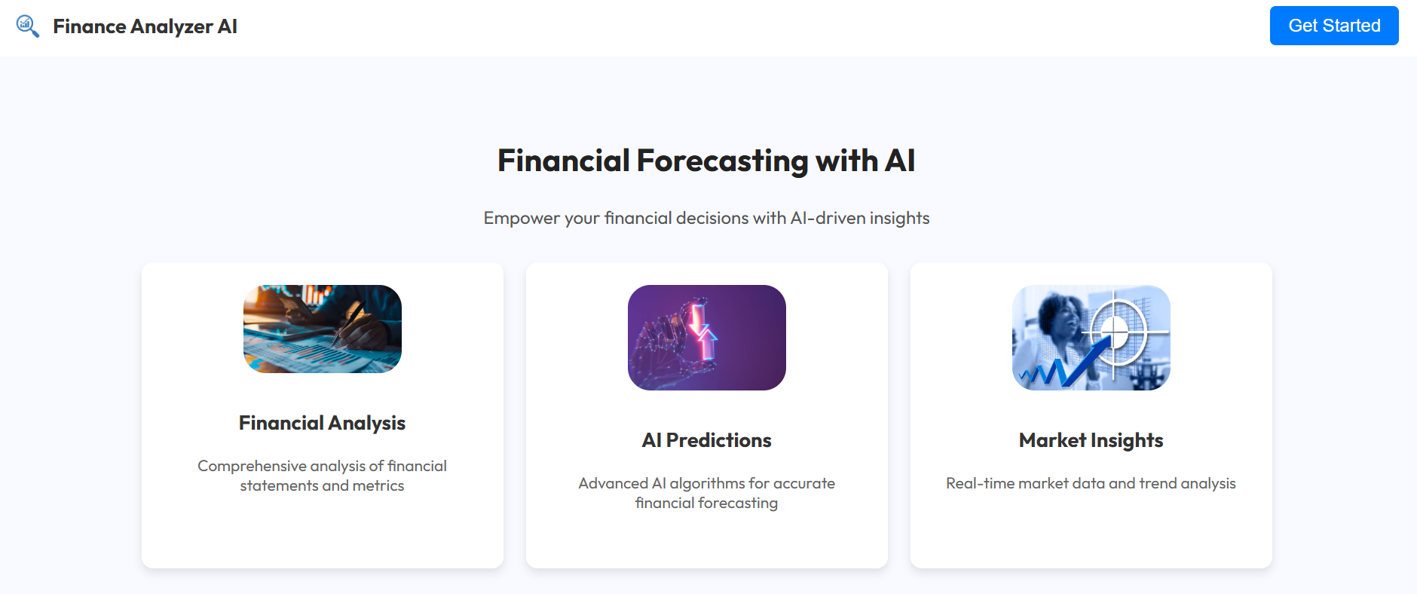



**Backend Documentation**

**Technologies Used:**

* **Backend Framework**: Flask

**APIs Implemented:**

1. **Chatbot API**: Handles user queries and returns responses.

**API KEY**: “Yahoo_finance API key”